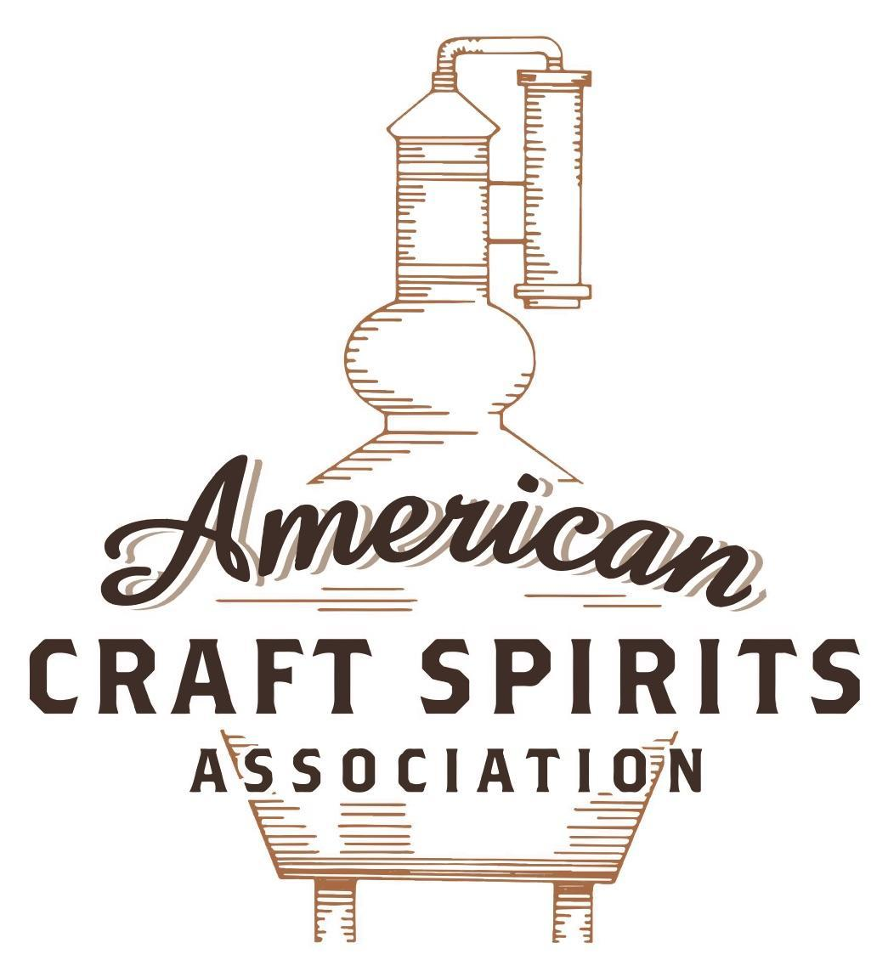
Spirits DtC Shipping Guide

This guide summarizes the direct-to-consumer shipping rules for distilleries in all 50 states and D.C. and also addresses the measures state governments have taken to ease delivery and shipping restrictions during the COVID-19 pandemic.

DtC Quick Guide Comparison

Out-of-State Distilleries  Can Ship Into State? |  |  |  | In-State Distilleries  Can Ship Within State?
State | Yes | No |  | State | Yes | No
AL |  | X |  | AL |  | X
AK | X |  |  | AK | X
AZ | X |  |  | AZ | X
AR |  | X |  | AR |  | X
CA |  | X* |  | CA |  | X*
CO |  | X |  | CO |  | X
CT |  | X* |  | CT |  | X
DE |  | X |  | DE |  | X
DC | X |  |  | DC | X
FL |  | X |  | FL |  | X
GA |  | X |  | GA |  | X
HI |  | X* |  | HI |  | ?*
ID |  | X |  | ID |  | X
IL |  | X* |  | IL |  | X*
IN |  | X |  | IN |  | X
IA |  | X* |  | IA |  | X*
KS |  | X |  | KS |  | X
KY | X |  |  | KY | X
LA |  | X |  | LA |  | X
ME |  | X* |  | ME |  | X*
MD |  | X |  | MD |  | X
MA |  | X |  | MA |  | X
MI |  | X |  | MI |  | X
MN |  | X |  | MN |  | X
MS |  | X |  | MS |  | X
MO |  | X |  | MO |  | X
MT |  | X |  | MT |  | X
NE | X |  |  | NE | X
NV |  | X* |  | NV |  | X
NH | X |  |  | NH |  | X*
NJ |  | X* |  | NJ |  | X*
NM |  | X |  | NM |  | X
NY |  | X* |  | NY |  | X*
NC |  | X |  | NC |  | X
ND | X |  |  | ND | X
OH |  | X |  | OH |  | X
OK |  | X |  | OK |  | X
OR |  | X |  | OR | X
PA |  | X* |  | PA |  | X
RI |  | X* |  | RI |  | X
SC |  | X |  | SC |  | X
SD |  | X |  | SD |  | X
TN |  | X |  | TN |  | X
TX |  | X |  | TX |  | X
UT |  | X |  | UT |  | X
VT |  | X |  | VT |  | X
VA |  | X |  | VA |  | X
WA |  | X* |  | WA | X
WV |  | X* |  | WV |  | X*

WI |  | X |  | WI |  | X
WY |  | X |  | WY |  | X

Notes:
*CA: If passed and signed into law, Senate Bill 620 would allow licensed distilled spirits producers in states other than California and licensed distilled spirits manufacturers or craft distillers in California who obtain distilled spirits direct shipper permits to ship directly to consumers in California
*CT: Consumers with appropriate permit may receive alcohol shipments
*HI: Consumers with appropriate permit may receive alcohol shipments; If passed and signed into law, Senate Bill 65 would allow licensed distilled spirits manufacturers in Hawaii and in states other than Hawaii who obtain direct shipper permits to ship directly to consumers in Hawaii
*IL: If passed and signed into law, Senate Bill 0532 would allow licensed distilled spirits producers in Illinois and in states other than Illinois who obtain distillery shippers’ licenses to ship directly to consumers in Illinois
*IA: If passed and signed into law, House File 639 would allow native distilled spirits manufacturers in Iowa and in states other than Iowa who obtain direct shipper permits to ship directly to consumers in Iowa and to consumers in states other than Iowa
*ME: If passed and signed into law, Legislative Document 1358 would allow distilleries outside of Maine with current manufacturer licenses and distilleries licensed in Maine who obtain spirits direct shipper licenses to ship directly to consumers in Maine
*NJ: (1) If passed and signed into law, Assembly Bill 3167 would allow a craft distillery licensees to ship no more than 9 liters of distilled spirits to a consumer in New Jersey; (2) If passed and signed into law, Senate Bill 3020 would allow craft distillery licensees in New Jersey or in states other than New Jersey to ship no more than 20 liters of distilled spirits to a consumer in New Jersey via common carrier
*NV: Licensed individuals can import one gallon per month of spirits for personal use and the out-of-state supplier must pay excise tax
*NH: If passed and signed into law, Senate Bill 125 would allow licensed liquor manufacturers who obtain direct to consumer shipping permits from the commission to ship directly to consumers in New Hampshire
*NY: Consumer may import up to 90L of liquor per year for personal use without a license; If passed and signed into law, Assembly Bill 3275 would allow licensed liquor manufacturers in states other than New York and licensed distillers and farm distillers in New York to ship no more than thirty-six cases (no more than nine liters per case) of liquor to consumers in New York
*PA: Consumer may place a special liquor order and distiller must ship to a PLCB-operated store
*RI: Distiller can only ship to customer if order was personally placed by customer at distiller's premises
*WA: If passed and signed into law, House Bill 1432 would allow licensed spirits manufacturers in states other than Washington to ship spirits to consumers in Washington
*WV: Distilleries, mini-distilleries, or micro-distilleries licensed in West Virginia or a state other than West Virginia who obtain private direct shipper licenses to ship to a consumer in West Virginia, however the shipments must be made to a retail liquor outlet

VIRGINIA

Shipment Outbound – Yes, if allowed by the importing jurisdiction’s laws (Va. Code § 4.1-201(B)).

Shipment Inbound – No, spirits must be sold at state-operated stores.

Shipment Intra-state – No, distillers have to sell to the VA Board or to consumers on their licensed premises (Va. Code § 4.1-201(A)(5)).

COVID-19 Measures – During the state of emergency, distillers will be able to ship to consumers in VA. Distillers will temporarily be considered an agent of the VA Board for the purposes of the sale of spirits and low alcohol beverage coolers. By signing an addendum to the Distillery Store Agreement and for a limited period of time, the distiller is authorized to provide spirits and low alcohol beverage coolers manufactured by or for, or blended by such licensee on the licensed premises through electronic or other orders and ship such orders to consumers and licensees in the VA. No distiller shall be permitted to sell more than six (6) bottles of spirits or two (2) cases of low alcohol beverage coolers to any one consumer or licensee per month. This addendum to the Distillery Store Agreement will continue as long as Virginia ABC stores are recognized as essential businesses under Governor’s Executive Order 53 and 55 or until further amended, modified or rescinded by the governor. As of July 1, the State of Emergency declared in response to COVID-19 has expired and all Executive Orders imposing COVID-19 restrictions are expired or terminated. S.B. 1299, signed and enacted into law on March 18, 2021, allows a distiller that has been appointed as an agent of the Board to deliver any alcoholic beverages the distiller is authorized to sell through organized tasting events and Board regulations to a consumer in Virginia for personal consumption. Deliveries can be made to a consumer’s vehicle if the vehicle is located in a designated parking area of the licensee’s premises or to such other locations as may be permitted by Board regulation. The owner or any agent, officer, director, shareholder, or employee of the licensee or permittee or an independent contractor of the licensee or permittee must perform all deliveries. (H.B. 1879 is the House version of the bill).
Distillery Shipping Privileges Link: https://www.abc.virginia.gov/about/media-room/2020/04062020-distillery-shipping-privileges
S.B. 1299 Link: https://lis.virginia.gov/cgi-bin/legp604.exe?212+ful+SB1299+hil
Citation (shipment)
Virginia Code
§ 4.1-201. Conduct not prohibited by this title; limitation.
A. Nothing in this title or any Board regulation adopted pursuant thereto shall prohibit:
3. Any person licensed to manufacture and sell, or either, in the Commonwealth or elsewhere, alcoholic beverages other than wine or beer, from soliciting and taking orders from the Board for such alcoholic beverages.
5. The granting of any retail license to a brewery, distillery, or winery licensee, or to an applicant for such license, or to a lessee of such person, a wholly owned subsidiary of such person, or its lessee, provided the places of business or establishments for which the retail licenses are desired are located upon the premises occupied or to be occupied by such distillery, winery, or brewery, or upon property of such person contiguous to such premises, or in a development contiguous to such premises owned and operated by such person or a wholly owned subsidiary.
B. No deliveries or shipments of alcoholic beverages to persons outside the Commonwealth for resale outside the Commonwealth shall be made into any state the laws of which prohibit the consignee from receiving or selling the same.
Link: https://law.lis.virginia.gov/vacode/title4.1/chapter2/section4.1-201/
Citation (COVID-19)
Consistent with Executive Order Fifty-One Declaration of Emergency due to Coronavirus (“COVID19”) and Executive Order Fifty-Three and further consistent with the purposes of the Authority as expressed in §4.1-101 et seq. of the Code of Virginia, and further consistent with the role of the Authority as a market participant as defined by the Supreme Court of the United States this Agreement is modified as follows:
1. Pursuant to this Agreement §4.1-119(D), the Distiller is an agent of the Board for the purposes of the sale of spirits and low alcohol beverage coolers, manufactured by or for, or blended by such distiller on the licensed premises. 2. Upon the execution of this Addendum to the Distillery Store Agreement and for a limited period of time, the Distiller is authorized to provide spirits and low alcohol beverage coolers manufactured by or for, or blended by such licensee on the licensed premises through electronic or other orders and ship such orders to consumers and licensees in the Commonwealth in accordance with the provisions of this Addendum as an agent of the Board. HOWEVER, no such distiller shall be permitted to sell more than six (6) bottles of spirits or two (2) cases of low alcohol beverage coolers to any one consumer or licensee per month.
3. Bottles of spirits shipped shall have a maximum capacity no more than 1.75 liters.
4. The direct shipment of spirits or low alcohol beverage coolers pursuant to this Addendum shall be by approved common carriers only.
5. The Distiller shall ensure the recipient is at least twenty-one (21) years of age; and that the recipient’s name and date of birth are recorded.

The American Craft Spirits Association (ACSA) is working diligently to give our members and industry partners relevant, current updates on statutes and regulations impacting production, sale and distribution of spirits. With the declaration of the novel coronavirus (COVID-19) in early 2020, many states have issued temporary policy changes or longer-term modernization of alcohol beverage laws. State statutes, regulations created by the state alcohol regulatory authority, as well as any other relevant guidance provided by such authorities (such as advisories, opinions, bulletins, etc.) were reviewed in creation of this document. No city or county ordinances were reviewed. Distillers should be aware that even in states where direct shipping is permissible, always remember to avoid shipping to dry counties. Please consult with your state guild or alcohol beverage authority for the most up-to-date information. This content is intended for educational and informational purposes only. ACSA's pro bono law firm of Malkin Law P.A. provided the core content found in this comprehensive overview of the spirits distribution after COVID-19. It was completed in August 2021 and will be updated regularly. If you have updates you would like to provide, please send to legislation@americancraftspirits.org or directly to the law firm at: ryan@malkin.law / malkin.law. Thank you.

